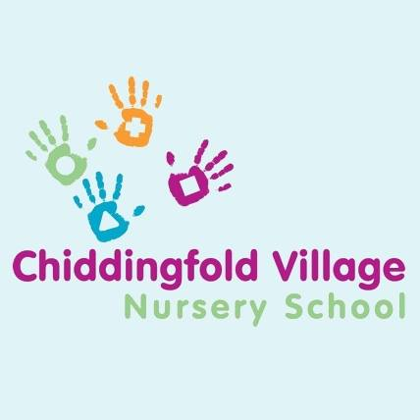
Schedule of fees

Registration Fee | £30.00
Hourly rate:
Children aged 2 years |  | £6.50*
Children aged 3 years or more |  | £6.50*
Additional sessions above agreed hours |  | £6.50* per hour
Other charges:
Administration charge associated with “plus 15 hours” funding; £10 per term.
Voluntary contribution to supplement “plus 15 hours” funding; £2 per hour.
Voluntary Snack donation £20 per term
Voluntary Craft Donation £20 per term
Late collection fee of £5.00 per additional 15 minutes.
Late payment fee of £20, plus daily interest of 3% above the Bank of England base rate charged on the outstanding amount.

Banking Details for BACS payments.

Lloyds Bank. 30-93-49
Account. Chiddingfold Village Nursery School. Account Number. 01146329

*Subject to change annually. You will be notified in writing in advance should our fees increase.

